CURRICULUM VITAE

Name: Adnan A.M. Aqrawi

LinkedIn Profile: (Adnan (A.M.) Aqrawi, PhD-DIC | LinkedIn)

Some Positions: Currently Chairman of the Board of FAB Group and Advisor in Energy & Innovation at Innergy Consultancy. Previously was a Project Leader-Innovation at Emerging Technologies and Innovation of Equinor, a Lead Geologist for Exploration - at Houston Office, Statoil USA-Gulf of Mexico, and a Business Development Managaer for Statoil ME-Iraq office, Jordan.

Date of Birth: 1958 (Aqra, Kurdistan Region, Iraq)

Nationality: Norwegian Citizen since 2005 (Originally Iraqi)

Membership: European Asso. Geoscientists and Engineers (EAGE)

Services Provider for the Energy Sector Globally:

- FAB GROUP Services:
- Norwegian Innovator (fabgroup.no)

TECHNOLOGY & FRONT-END ENGINEERING
State of the art technology provider, offering such technology and expertise as production optimization, gas emission reduction, energy storage and other green technologies.

EPCI & MODIFICATION
Lean Project Execution by providing fast-track projects from feasibility to execution and further into operations. Projects are executed according our unique agile and efficient execution models.

DIGITALIZATION
Virtual Engineering and Visualization (VEV) via providing cutting edge digital solutions for engineering, installation and operations improving the safety, quality and cost efficiency in projects.

- INNERGY CONSULTANCY AQRAWI (ICA) Services:
- (Innergy consultancy Aqrawi (icaqrawi.com)

FIND TECHNOLOGICAL SOLUTIONS for challenges facing the O&G companies

ASSIST STARTUPS to mature their technologies and build their business model

RUN INNOVATION WORKSHOPS to solve problems facing any project or group by using our unique ICA Innovation Toolbox

SUPPORT O&G COMPANIES in Exploration, Production and Development of oilfields providing data, reports and consultancy

STRATEGY CONSULTING to set the right vision for reaching the main business goals

TRAINING & COURSES regarding Petroleum Geology of ME (Iraq) and Innovation, performed at client offices or at key cities within the MENA region

Key Qualifications and Experiences:

- More than 40 years of international experiences in O&G and academia as an Innovative Petroleum Geoscientist in E&P for several IOCs and NOCs. I’ve worked in multidesciplinary teams while; in Iraq with local NOCs and research centres (1984-1990 & 1993-1995), in Malaysia with PETRONAS, (1995-1997), and in Norway with Smedvig Technologies / Roxar (1997-2000), and later Statoil (changed name to Equinor in 2018) from 2001 until end of April 2023.

- Innovation expert for the last 11 years, running crowdsourcing campaigns and multi-discipline workshops for solving strategic challenges in the energy sector. Additionally, I’ve helped mature many new Blue Sky and Radical ideas via prototyping and coordinated them to become potential new technologies/software/concepts via incubation, to save resources efficiently.

- Strong experiences in Business Development, Negotiations, and Strategy. I’ve attended several distinct courses from Developing of International Negotiators (DIN). I’ve also been involved in many direct businesses talks with several NOCs and IOCs in MENA region and evaluated many opportunities for Statoil (Equinor) worldwide, particularly while was a Business Development Mnanager for Iraq and Lead Exploration Professional within INT MENA (2006-2008 & 2011-2012).

- Highly experienced explorationist in; play fairway mapping, data-room reviewing, petroleum systems analysis, sequence stratigraphy, statistical geology, IOR & field development in addition to seismic interpretation.

- As a sedimentologist/petroleum geologist with PhD from Imperial College-London since 1993, has in-depth knowledge of the characterization of carbonate and sandstone reservoirs in the Middle East, North Africa, SE Asia, North Sea, Gulf of Mexico and Caspian Sea.

- Published over 50 scientific articles in international journals and co-authored a book on (The Petoleum Geology of Iraq), April 2010, which was sponsored thankfully by Statoil (Equinor) and BP (www.petgeoliraq.com).

- Also was Full Professor (2015-2016) lecturing at the Department of Petroleum Technology, University of Stavanger (UiS) and developed an MSc course on Carbonate Reservoir Geology.

- Supervised postgratuate research for MSC in Iraq and recently in Bergen university in Norway.

- In addition, ran several field trips and classes for various O&G experts on Middle Eastern (ME) Petroleum Systems, particularly in Iraqi Kurdistan and northern Arbian Plate (Jordan and Saudi).

- Very knowledgable about competence building and learning solutions for people and organization, which I utilized while working with universities and while I was the Program Manager for People and Leadership Development learning of Exploration and Petroleum Technology at Statoil Academy. Furthermore, I employed this as part of the Corporate Social Responsibility projects for cooperative puposes with local partners and NOC stakeholders in MENA countries where Statoil operates.

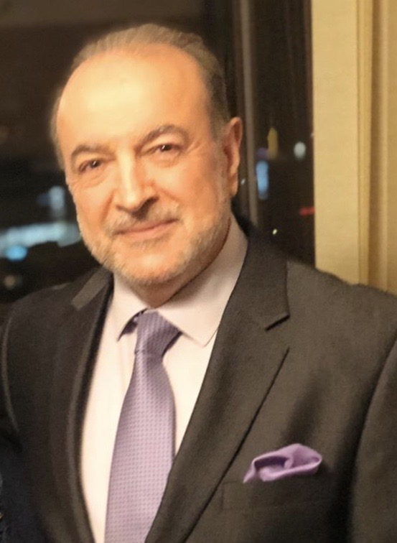

Publications:
- Published a book and 5 chapters within books or special publications as follow:

- AQRAWI, A.A.M., Goff, J, Horbury, A. and Sadooni, F.N. 2010. The Petroleum Geology of Iraq. Scientifc Press, UK, London, 424p. (www.petgeoliraq.com)
- Mahdi, T. A. and AQRAWI, A.A.M. 2018. Role of facies diversity and cyclicity on the reservoir quality of the mid-Cretaceous Mishrif Formation in southern Mesopotamian Basin, Iraq. Geol. Soc. Spe. Pub. 435. Reservoir Quality of Clastic and Carbonate Rocks: Analysis, Modelling and Prediction. Armitage et al. (eds).
- AQRAWI, A.A.M., Al-Hadidy, A., and Horbury, A. 2013. Hydrocarbon potential of the Upper Permian Chia Zairi Formation in Iraq. Chapter 9, In M. Popperlreiter, Permo-Triassic Sequence of the Arabian Plate. EAGE Special Publication, 199-218.
- AQRAWI A.A.M., Domas, J. and Jassim, S.Z., 2006. Quaternary Deposits, Chapter 15, in: Jassim, S.Z. and Goff. J.C. (eds.), Geology of Iraq. Dolin, Prague and Moravian Museum, Brno. pp. 185-198.
- Williams, D. and AQRAWI, A.A.M. 2006. Utility of using acoustic impedance data in the stochastic modeling of a carbonate reservoir, in T.C. Coburn, J.M. Yarus, and R.L. Chambers (editors): Stochastic modelling and Geostatistics, Principles, Methods and Case Studies; Vol. II: AAPG Computer Applications in Geology; 5: 253-268.
- Sadooni F.N. and AQRAWI, A.A.M., 2000. Cretaceous sequence stratigraphy and hydrocarbon potential of the Mesopotamian Basin, Iraq. In A.S. Alsharhan and R.W. Scott (eds.), Middle East Models of Jurassic/Cretaceous Carbonate Systems. SEPM Spec. Publ. No. 69: 315-334.

- Published more than 55 papers on different geological topics in various international geological journals, in addition to tens of abstracts in conferences worldwide. Some selected publications are as follow:

- Mitchel A.F., Gilding D. and AQRAWI, A.A.M. 2022. Consolidation of weak sand zones in hydrocarbon reservoirs using microbial biofilms. Disclosed by Equinor Energy AS. Published in paper journal by Questel Research Disclosure, The Industry standard Research Disclosure Publication Service.
- AQRAWI, A.A.M., Masri, A., and Horbury, A.D. 2021. Review of Lower Paleozoic reservoir prospectivity of western Iraq with reference to Jordan. Iraqi Geological Journal, 52(2B): 24-57.
- AQRAWI, A.A.M. and Badics, B. 2015. Geochemical characterisation, volumetric assessment and shale-oil/gas potential of the Middle Jurassic–Lower Cretaceous source rocks of NE Arabian Plate. GeoArabia:20, 99-140.
- Mahdi T. A. and AQRAWI A.A.M. 2014. Sequnce stratigraphic analysis of the mid-Cretaceous Mishrif Formation, southern Mesopotamian Basin, Iraq. Jouur. Petrol. Geol. 37: 287-312.
- Mahdi, T. A., AQRAWI, A.A.M., Horbury, A., and Sherwani, G.H. 2013. Sedimentological characterization of the mid-Cretaceous Mishrif reservoir in southern Mesopotamian Basin, Iraq. GeoArabia, 18: 139-174

Education:

1990-1993; PhD in Sedimentology, and 1994, DIC (Diploma of Imperial College) in Sedimentary Geology (in lacustrine and deltaic clastic sediments) from Imperial College of Science, Technology and Medicine, University of London, U. K.

1981-1983; MSc in Petroleum Sedimentology (of carbonate reservoirs) from College of Science, University of Baghdad, Iraq.

1976-1980; BSc in Geology (Geochemistry) from College of Science, University of Baghdad, Iraq (Gratuated with Honour rank no. 1 among 113 students).

Employment Record:

September 2023-Present; Chairman of the Board of FAB Group: FAB Group is Norwegian Innovator (fabgroup.no), which has three main offices in Norway (Stavanger), Oman (Muscat) and India (Bombay). It is Providing innovative and proven solutions worldwide for E&P and development of oilfields. In addition, FAB provides top class engineering expertise together with developing and investing in cutting edge technologies.

April 2023-Present: Advisor in Energy and Innovation at Innergy Consultancy (Innergy consultancy Aqrawi (icaqrawi.com): Advising on various aspects of Innovation and Energy, particularly in Middle East region, and finding the best technological solutions for every problem or challenge that a company may be facing through the whole value chain of E&P of O&G and Renewables using our unique ICA Innovation Toolbox and also liking the clients to the right innovative technology/company in Norway.

September 2021-April 2023; Various positions across Statoil/Equinor.

2014-July 2016; Part-time Full Professor, Petroleum Technology Department, University of Stavanger (UiS). Develpoed a new MSc teaching course and lab work on Carbonate Reservoir Geology, for the first time to be tought at this university in Norway.

2000- 2001; Gological Advisor, PetroSediment Consultancy, Stavanger, Norway. Involved in Basin Analysis and Exploration Assessment, in addition to Reservoir Evaluation, Modelling and Characterisation, for the Middle East and the Eritrean Red Sea.

1997-1999; Advisor Geology, Smedvig Technologies AS and then Roxar ASA, Stavanger-Norway. Working as a geologist-sedimentologist on reservoir characterization, and stochastic and deterministic 3D-modelling of various reservoirs for fields in the North Sea, Middle East, and the Caspian Sea using RMS software.

1995-1997; Senior Sedimentolgist in Petronas Research Centre, Kuala Lumpur, Malaysia. Employed as Petroleum Geologist to integrate all the available data and information about Paleozoic of the Middle East and North Africa for exploration and development purposes. In addition, as a Sedimentologist Researcher, led and participated in more than 10 service petrographic and mineralogical projects at PRSS on clay mineralogy and reservoir characterisation of many reservoirs across Malay and Sarawak Basins.

